- Product mix — revenue share and margin contribution by product
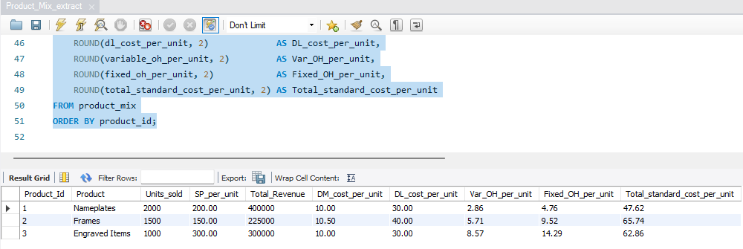

- Full FY2026 variance bridge (Actual vs Flexible vs Static Budget)
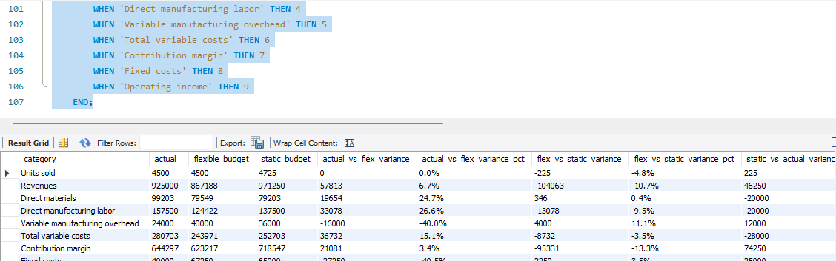

- Biggest unfavourable cost drivers vs flexible budget
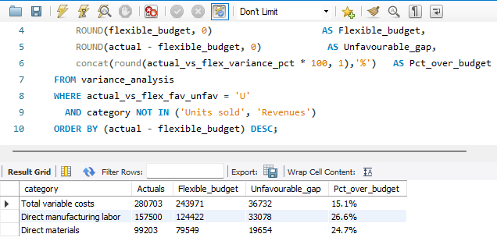

- Production volume growth vs COGS growth (checks if costs are outgrowing units)
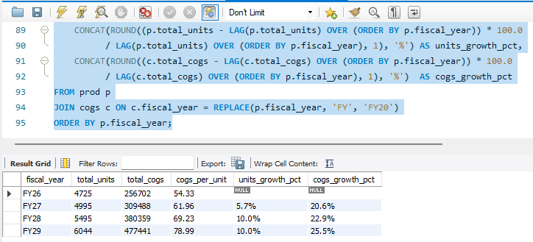

- Materials vs labour vs overhead cost mix per product

